**Phase 4: Process Automation (Admin)**

This phase covers automating business processes in Salesforce using admin tools like Validation Rules, Workflow Rules, Process Builder, Flow Builder, and more.

**1️⃣ Validation Rules**

**Purpose:** Ensure data integrity by enforcing specific criteria before a record is saved.

**Key Points:**

* Use formulas to define conditions.
* Display error messages when validation fails.
* Example: Ensure End_Date__c is after Start_Date__c.

**Steps to Create:**

1. Go to **Setup → Object Manager → [Object] → Validation Rules**.
2. Click **New**.
3. Enter **Rule Name** and **Description**.
4. Define the **Error Condition Formula**.
5. Enter **Error Message** and location (field-level or top of page).
6. Save and activate. 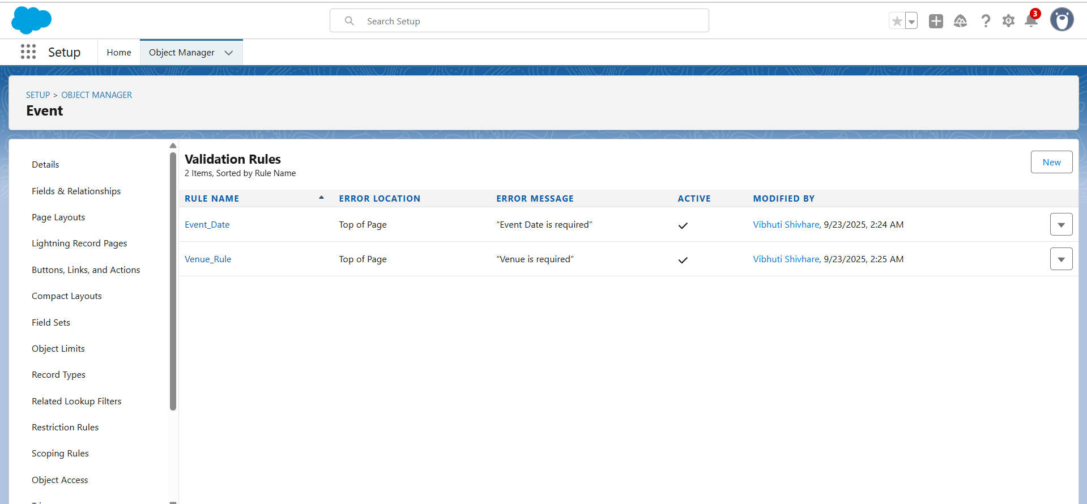

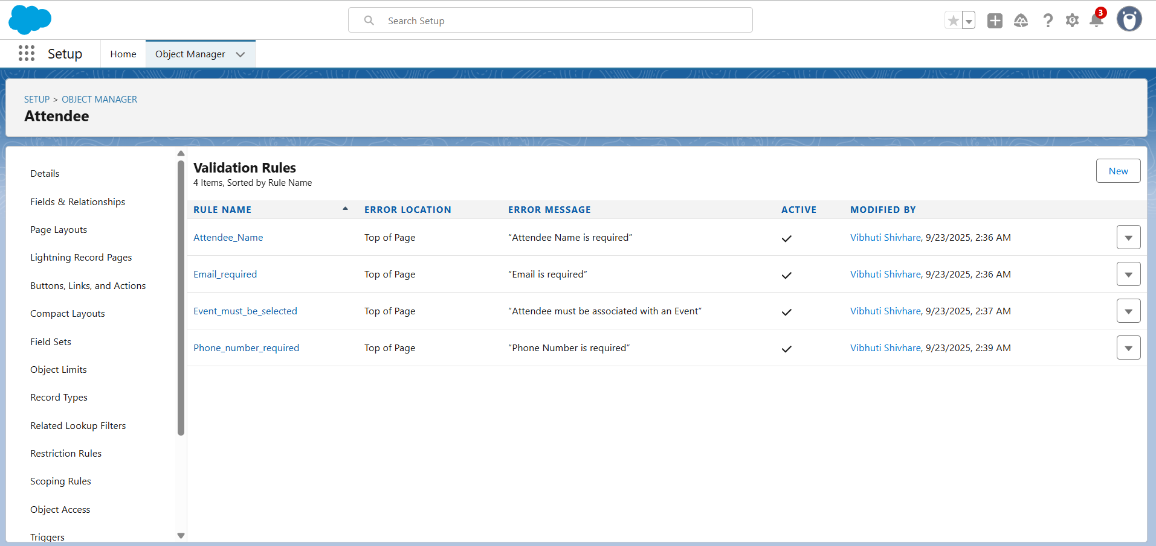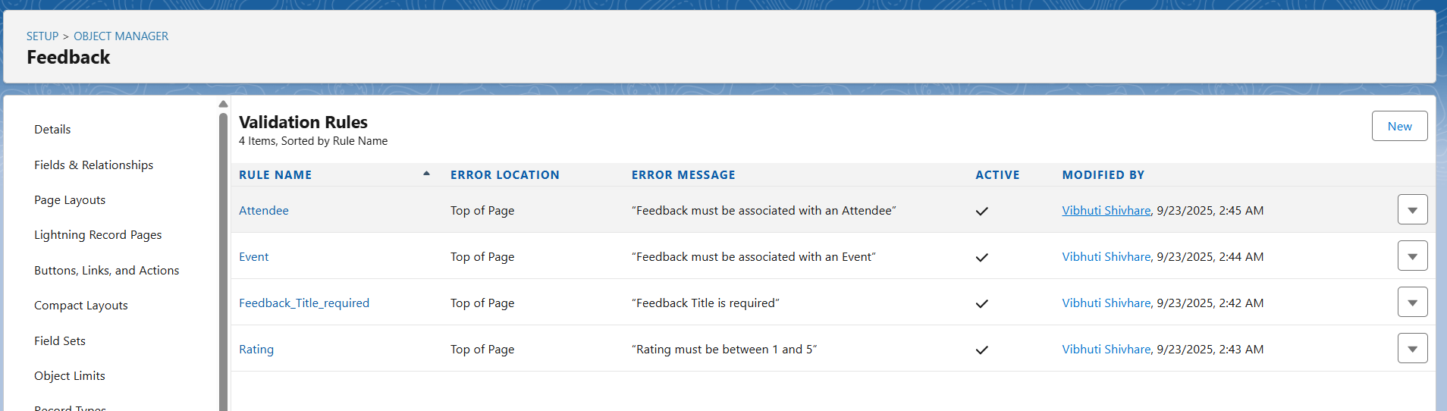**2️⃣ Workflow Rules**

**Purpose:** Automate standard internal processes like sending emails, updating fields, or creating tasks based on record criteria.

**Components:**

* **Rule Criteria:** When the workflow triggers.
* **Workflow Actions:** Email Alerts, Field Updates, Tasks, Outbound Messages.

**Steps to Create:**

1. Go to **Setup → Workflow Rules**.
2. Click **New Rule** → Select Object → Next.
3. Define **Rule Criteria**.
4. Add **Workflow Actions**.
5. Save and **Activate**. 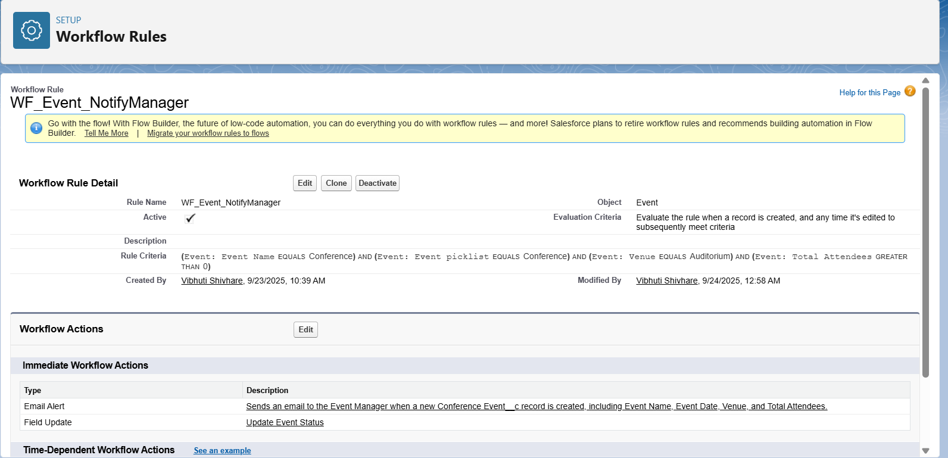

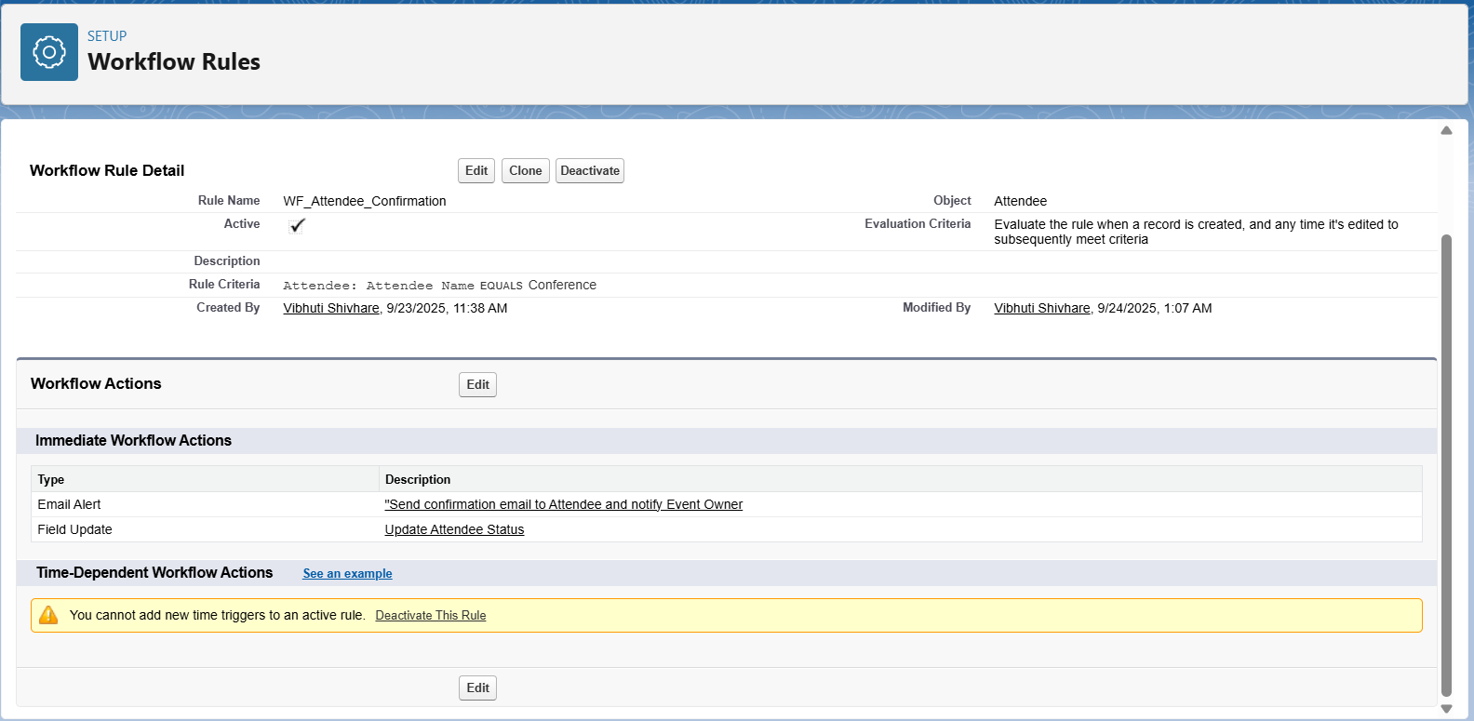

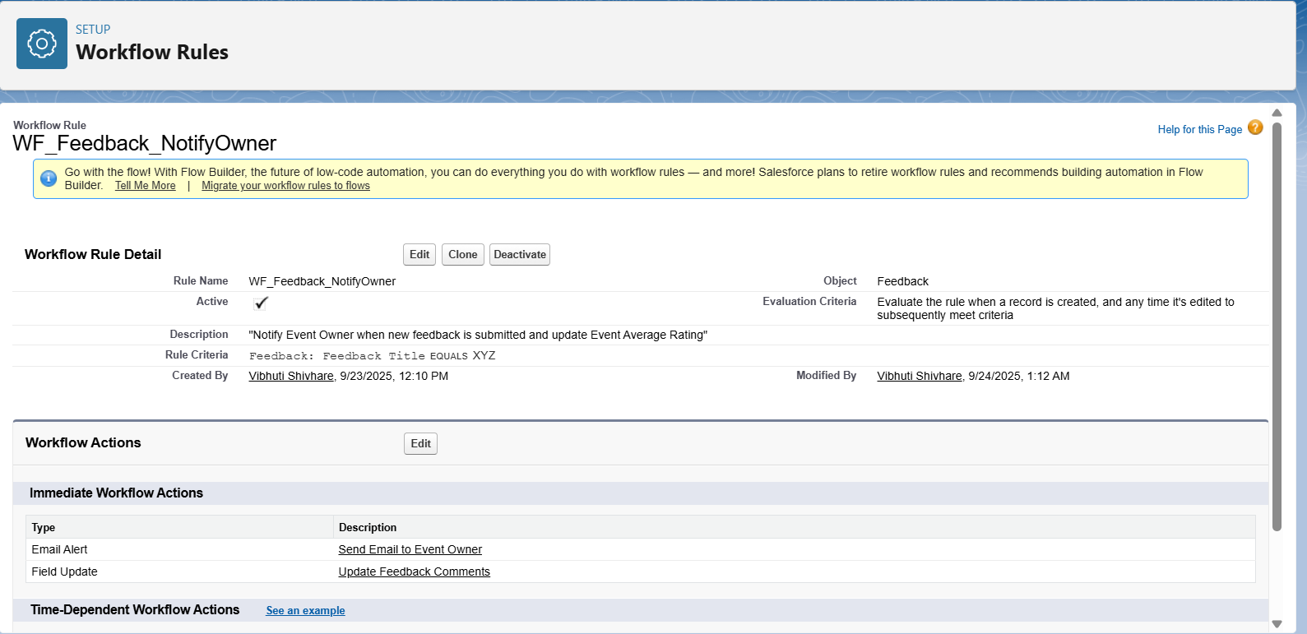

**3️⃣ Process Builder**

**Purpose:** Advanced automation that can update related records, launch flows, send emails, or call Apex.

**Steps to Create:**

1. Go to **Setup → Process Builder → New**.
2. Enter **Process Name** and select **The process starts when…**.
3. Add **Criteria** for triggering actions.
4. Add **Immediate or Scheduled Actions** (Email Alerts, Field Updates, etc.).
5. Save and **Activate**.

**4️⃣ Approval Process**

**Purpose:** Automates record approvals with defined steps and approvers.

**Steps to Create:**

1. Go to **Setup → Approval Processes → Create New Approval Process**.
2. Choose **Use Standard Setup Wizard**.
3. Define **Entry Criteria** and **Approvers**.
4. Specify **Approval Steps** and **Actions** (Email Alerts, Field Updates, Tasks).
5. Save and **Activate**.

**5️⃣ Flow Builder**

**Purpose:** Powerful automation tool to create **Screen Flows, Record-Triggered Flows, Scheduled Flows, and Auto-launched Flows**.

**Types:**

* **Screen Flow:** For user interaction.
* **Record-Triggered Flow:** Automates actions on create/update/delete.
* **Scheduled Flow:** Runs at specified intervals.
* **Auto-launched Flow:** Runs without user interaction, usually from Process Builder or Apex.

**Steps to Create:**

1. Go to **Setup → Flow → New Flow**.
2. Select **Flow Type** → Click **Create**.
3. Drag **Elements** to define logic (Screen, Get Records, Update Records, Decision).
4. Connect elements → Save → **Activate**.

**6️⃣ Email Alerts**

**Purpose:** Automatically send emails based on triggers.

**Steps to Create:**

1. Go to **Setup → Email Alerts → New Email Alert**.
2. Choose **Object**, **Recipients**, and **Email Template**.
3. Link to Workflow, Process Builder, or Flow.
4. Save.

**7️⃣ Field Updates**

**Purpose:** Automatically update field values based on conditions.

**Steps to Create:**

1. Can be used with Workflow, Process Builder, or Flow.
2. Define **Target Field** and **Update Logic** (Formula, Static Value, Related Field).
3. Save and activate.

**8️⃣ Tasks**

**Purpose:** Automatically create tasks for users to follow up on records.

**Steps to Create:**

1. Available via Workflow, Process Builder, or Flow.
2. Define **Task Subject, Due Date, Priority**, and **Assigned To**.
3. Save and activate.

**9️⃣ Custom Notifications**

**Purpose:** Send real-time notifications to users in Salesforce mobile, desktop, or in-app.

**Steps to Create:**

1. Go to **Setup → Custom Notifications → New**.
2. Define **Notification Name, Channels**, and **Target Object**.
3. Use Workflow, Process Builder, or Flow to trigger notifications.
4. Save.